The Earth Reels Like A Drunkard
September 20, 2017
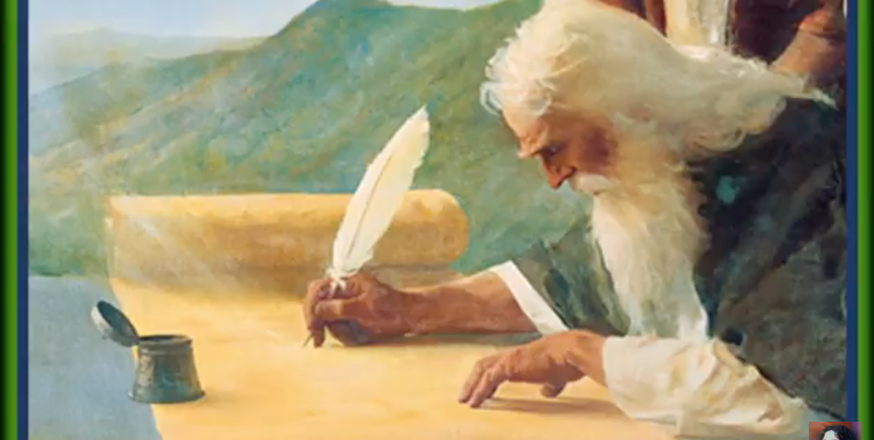
Dear Lord, please give us a spirit of supplication and intercession to lift up those who are suffering in this hour.

Dear ones, the Earth is reeling like a drunkard and all we can do is drop everything and pray. This is a time of extreme agony for the Lord and it explains why so many things have been extremely difficult, even on a personal level, for all of us.

Please pray, pray, pray the Divine Mercy Chaplet and do what you can to fast for the salvation of souls. For the last week, He has been giving me the Scriptures about His return, how He ascended into Heaven and how He will return again the same way. Keep your eyes fixed on the prize, Heartdwellers. Let nothing take you away from the vision of His return—and soon!!!!

I do not know what the date is, but He has told me over and over again that the Earth will reel like a drunkard for all the sin that is being committed. I totally expected these terrible things to be happening very soon from the way He has been weeping and weeping. And while this movement is going on globally, I want you to know there are things going on, on our own continent, to strike at the heart of the wickedness that has tried to destroy our country.

We are going to make it through this…but let’s do it in prayer with our eyes on souls that are not saved.

Ezekiel has been bed-ridden, as many of you know, for several weeks. And seeing visions of children all over the world, standing alone, shaking and crying, with no one to help them. Children in third world countries being caught under rubble and suffering unbelievable torments. Please pray for the children and those in the world who will be hit the hardest.

The signs are everywhere. He is coming back soon. But until He does we have a lot of work to do. It certainly explains the sad music He has been giving me.

Right now, I would ask all of you to have communion services along with the Divine Mercy Chaplet, and fast as you can. There are many different kinds of fasts. They can be an abstinence fast, or can be a total fast. Or fast on bread and water. Do what you can do, and seek the Lord about it before you commit yourself.

Devote yourselves to prayer and keep vigils. Please don’t spend any time on foolish things. Forget about yourselves and be there for Him. Please let us all be there for Him and lead your families in prayer for the places disaster has been striking. Speak to them more seriously that these are the signs the Lord promised before His return and there is NO MORE TIME for sitting on the fence.

Those who sit on the fence will be left behind. And He is raising up the cry from many, many ministries…there is no more time, just as it is written in Matthew 24.

Then Jesus said: “Watch out that no one deceives you. For many will come in my name, claiming, ‘I am the Messiah,’ and will deceive many. You will hear of wars and rumors of wars, but see to it that you are not alarmed. Such things must happen, but the end is still to come. Nation will rise against nation, and kingdom against kingdom. There will be famines and earthquakes in various places. All these are the beginning of birth pains.
Matt. 24: 5-8

We are in labor, Heartdwellers…real labor. And what He has told us about the evil underground government—literally and figuratively— UNDER ground government is taking place even as we speak.

It is written clearly here in Isaiah 24:
The floodgates of the heavens are opened (HURRICANES), the foundations of the earth shake. 19The earth is broken up, the earth is split asunder, the earth is violently shaken. 20 The earth reels like a drunkard, it sways like a hut in the wind; so heavy upon it is the guilt of its rebellion that it falls—never to rise again. Isaiah 24:18-20

And this is an amazing confirmation of what He's told us about the governments that are evil

In that day the Lord will punish the powers in the heavens above and the kings on the earth below. They will be herded together like prisoners bound in a dungeon; they will be shut up in prison and be punished a after many days. Isaiah 24:21-22

And for those of you who know about the fallen angels, the aliens, and how they are inhabiting the lower levels of the Earth, and conspiring with the evil governments of this world. To overthrow human-kind - this is another amazing confirmation of what's going on:

"In that day, the Lord will punish the powers in the heavens above, and the kings on the Earth below. They will be herded together like prisoners, bound in a dungeon."

That paints an amazing picture of exactly what is going on with these underground cities in collusion with 'aliens'. Who are not aliens, but fallen angels with a physical form.

Let us lift up the world to the Father, Heartdwellers, and beg for His mercy. And please, hold Jesus tenderly in your arms, for great is His suffering.

I'll post the link to the Divine Mercy Chaplet after this video.

https://www.youtube.com/watch?v=qRYEP4bVDHU

